Answer 1: (2) K-nearest neighbor, (4) Decision tree and (5) Logistic regression

Answer 2: blue

Answer 3: Curse of Dimensionality

Answer 4: (3) Principal Component Analysis (PCA)

Answer 5:

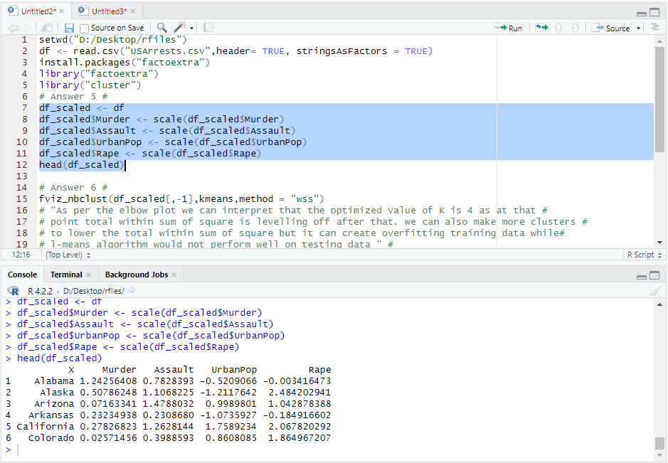

Answer 6:

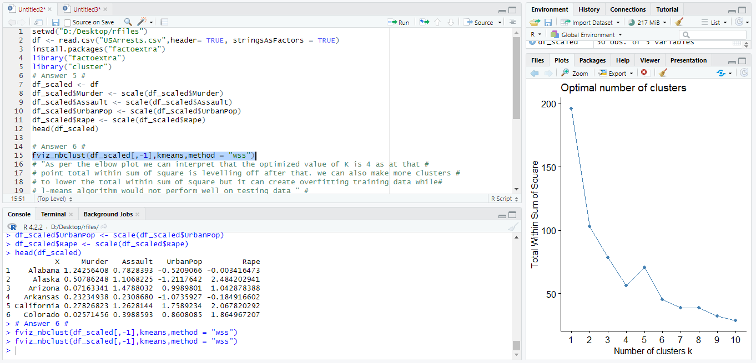

"**As per the elbow plot above we can interpret that the optimized value of K is 4 because after that**

**Point total within sum of square is leveling off. We can also make more clusters**

**To lower the total within sum of square but it can create over fitting training data while**

**K -means algorithm would not perform well on testing data**”.

Answer 7:

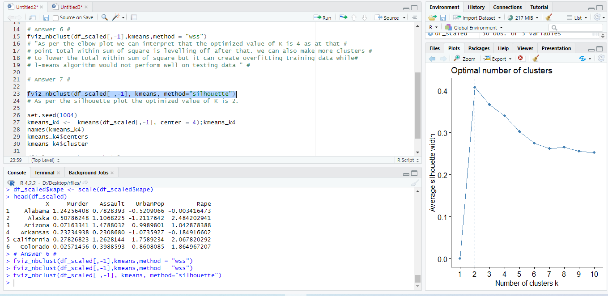

In Silhouette method the optimal number of clusters K is the one that maximizes the average silhouette in a range of possible values of k. so as per the silhouette plot the optimized value of K is **2**.

Answer 8:

